Key Determinants of KICT Student Satisfaction

Usamah Hafiz Jaafar G1816643,

International Islamic University Malaysia

**Table of Contents**

1. INTRODUCTION 3

2. PROBLEM STATEMENT 4

3. RESEARCH QUESTION 5

4. RESEARCH OBJECTIVES 6

5. LITERATURE REVIEW 8

5.1 Student Satisfaction 8

5.2 Teaching, Administration and other service and support staff 9

5.3 Facilities 10

5.4 Course Content Structure 10

6. RESEARCH DESIGN 11

6.1 Research Plan 12

7. INSTRUMENT DEVELOPMENT (SURVEY) 13

8. DATA COLLECTION PROCEDURES 20

9. STATISTICAL ANALYSIS 22

10. RESULTS 25

11. DISCUSSION 27

12. REFERENCES 28

**1. INTRODUCTION**

University is an institution of higher or tertiary education, which awards an academic degree in different field of studies within 4 to 5 years of studies. It is an institution that acknowledges achievement that industry will look for student to be hired by employers. It is a place where the secondary students from secondary school intent to further their studies in a higher level of the related studies that students are interested to further in a specific field. It is also known as a place to learn something in a very deep and academic way. The reason students want to further their studies in university to seek knowledge and pursue career that interest them.

Universities tend to bundle their offerings which includes core services including knowledge, intellectual abilities, interpersonal skills, and communication skills. Universities offer actual services through learning, teaching and research that leads to acquisition of degrees. Other services like infrastructure, building, transportation, logistics facilities, libraries, labs, computer labs, hostel facilities, medical, sports, and class room facilities coupled with administrative support makes up the environment of the Universities.

Student satisfaction is an issue of importance by University authorities and is a telling reflection on the service quality provided. This is evident from the fact that the impact of educational services provided by a university on the satisfaction level of its students has largely been diligently surveyed. Universities are where students learn and acquire all necessary skills and abilities that satisfy needs of potential employers out there in job market.

Hence, the research is investigating and find the level of satisfaction among the KICT students from the service that has been provided by KICT, IIUM. The outcomes of the research are to measure KICT students level of satisfaction in teaching and learning, and provide recommendations for future improvement.

**2. PROBLEM STATEMENT**

As some of us are KICT students, there are complaints among KICT students itself in satisfaction level that the services provided in this KICT. Thus, this research conducted to investigate what are the factors that might influence for this kind of sentiment. The complaints were coming from students itself especially from undergraduate students of KICT as those people have spent a lot of time in that KICT building especially for doing assignment and attending the lectures. For undergraduate students, they need to enrol 18 credit hour per semester thus leading them to spent a lot of time in KICT building. The complaints also was coming from postgraduate students as most of their time spent inside the KICT workspace to conduct their own research but the complaint is not as much as undergraduate students. The reason of this research is to stop listening about complaints and do our part as the researcher to identify whether this compliants are true or not and then try solving those problems for better improvement. In order to improve and provide the best facilities, this research wants to know the sentiment of our current enrolled student.

**3. RESEARCH QUESTION**

The research conducted is based on three constructs or factors that has been decided by us. The factors that has been decided are the most crucial part as it is the problem that the students in KICT facing every day. The questions that might be asked for this research are facilities, course content structure and teaching and admin staff, service and support provided by KICT faculty.

Those three factors are the most important especially for the students to be able to gain knowledge in this faculty that might lead into satisfaction in KICT faculty. For the facilities factor, the question will be asked based on wireless fidelity internet and network connection whether the connection is fast enough for students to do some academic research, classroom condition in term of air condition, LCD, chairs, tables, toilet condition, library in term of condition and the source of information provided and the workspace provided whether the condition for the workspace is good enough, reliable and accessible at all time.

For the course content structure, the question will be based on whether the subject taken has enough hands for the students to practice, the course enrolled is up to date and the course that has been taken so far is industry relevant.

For the teaching and admin staffs, service and support factor, the question will be based on whether administrative is responsive enough to solve the problems faced by the students and the lectures, support staff is timely and lectures or academic staffs like tutors have established good support with the students.

Those questions will be asked for the survey that will be conducted to get the result of those factors. Hence, for the research questions are:

What are the determinants of KICT Student satisfaction ?

Does the facilities provided in KICT influence KICT Student satisfaction ?

Does the course content and structure provided in KICT influence KICT Student satisfaction ?

Does Teaching, Administration and Other Service and Support influence KICT Student satisfaction ?

**4. RESEARCH OBJECTIVES**

The objective of this research is to investigate the influence of facilities, course content structure and teaching and admin staff, service and support to measure overall satisfaction level of KICT students. By using those factors, the research conducted will manage to gain result as it is the things that students are always dealing with it. For the facilities factor, WIFI connection is crucial as we are now living in 21st century where the knowledge the students gain not only from the academic staff but also from the internet connection.

Internet nowadays is the source of information as the students will rely on it regarding on solving the problems on assignment, project and research. It is crucial part and if it is not taken this issue seriously, it might impact the students’ performance in term of academic thus effect the satisfaction level for KICT. For the classroom, it should be as conducive as the students would be able to focus when attending the class. The classroom also should have good condition and enough of chairs, tables and computer especially IT students are dealing with programming and IT related stuffs. Toilet, Library and Workspace are the important part in KICT as the students always stay in this building for a very long time especially for the Final Year Project students as they need to use all the facilities to complete their project. The satisfaction level would be decrease if these facilities could not be provided to them.

As for the course content structure, the question will be based on the subject whether the subject has enough hands on. The students will learn about the theory part which is good. However, it would be better if the students have been exposed to hands on learning and practicality of the certain subject that might be useful for the students to gain knowledge in a very attractive way. The other question will be considered is whether the course is up to date. This is important especially students learning IT whereby IT will move every second in term of technology achievement. The programming language for the past ten years might not be useful anymore for them to get into working environment. If those IT students are still learning those things, it just wastes their time. Another part that has been a concerned is the relevance of the course taken from the industry perspective. Some subject that has been taken is not related to what the industry really needed from the fresh graduates. For example, mathematics, the industry actually doesn’t care much whether we are good at mathematics or not as long as they want to know on how to deal with the tools needed.

For teaching and admin staff, service and support, three questions that has been addressed to get data from this factor. The first question that would be asked is administrator is responsible or not. This is important as students learning process has been organized by this department. If the administrator cannot handle this part, the students may face difficulties in enrolling for this course thus make them unhappy about this faculty. The second question that would be asked is the timeliness of support staff. As we all know that the building for each faculty must be handled and maintained in order for the facilities to be run smoothly. Some problem may be faced by the students such as air conditioning problem, classroom cannot be accessed and etc. Thus those problems will be channelled to support staff in order to solve those problems. If the service is late or not responsive, it might be a problem for the students to focus on their studies thus it might affect the satisfaction level to this faculty. Last but not least is the academic staffs has established good support with students. This is important because some students might have problem during studies. It is the responsibility for the lecturers to assist them to the correct path of the studies so they could understand better in related field. Thus this might affect the satisfaction level of this KICT among the students.

**5. LITERATURE REVIEW**

The literature review was done by reviewing each independent and dependent variables in order to explain the connection and consistencies between the variables based on the related literature and theories. Articles were chosen based on the strength of each variables covered in their respective articles. The variables in this research are Student Satisfaction, Facilities, Teaching, Administration and other Service and Support staff, and Course Content Structure.

**5.1 Student Satisfaction**

The fulfilment of one’s needs, wishes or expectations or needs, defines Satisfaction. It is an emotional reaction to a product or service experience (Spreng & Sin­gh, 1993). Elliott and Shin (2002), describe student satisfaction as the favorability of a student’s sub­jective evaluation of the various outcomes and experiences associated with education. The formation of student satisfaction is a multi-di­mensional process influenced by many factors (Sandberg Hanssen & Solvoll, 2015). Petruzzellis, D’Uggento, and Romanazzi (2006) identified 19 variables critical to student satisfaction; these can be classified under the headings of facilities , students services and, teaching services, and student life. Also, the physical environment – the layout, lighting and over­all feel of the classrooms, the appearance of buildings and grounds, and overall cleanliness – has also been found to significantly contribute to student satisfaction with the ser­vice provided (J. Douglas, A. Douglas, & Barnes 2006). Martirosyan (2015) identified some commonalities of a number of studies that have examined factors that affect student satisfaction, which include the quality of programmes, instructional effectiveness, student support facilities, internet and library access, administrative staff efficiency, the college environment, and individual char­acteristics such as gender, ethnicity and age.

**5.2 Teaching, Administration and other service and support staff**

Findings by Hill, Lomas, and MacGregor (2003) stress the importance of teaching staff, and reported that the quality of the teachers is one of the most important factors in the provision of high-quality education. Marzo-Navar­ro, Pedraja-Iglesias, and Rivera-Torres, (2005) state that teaching staff are the main actors in a university, exercising the largest positive influence on student satisfaction. Tsinidou, Gerogiannis, and Fitsilis (2010) discovered that communication skills of academic staff was the most important criterion, followed by friendliness/approachability. Arambewela and Hall (2009) found that the education construct highlights the fact that feedback from lecturers, good ac­cess to lecturers and quality of teaching are perceived to be the most important variables influencing student satisfac­tion. To ensure a high level of student satisfaction, all employees of a university should adhere to the principles of quality customer service, be it front-line contact staff involved in teaching or administration or non-contact staff in management or administrative roles (Banwet & Datta, 2003). Sohail and Shaikh (2004) found that the contact personnel were the most influencing factor in students’ evaluation of service quality. Of utmost important to students was that the office had a professional appear­ance, smartly dressed staff and were never too busy to help, and convenient office hours. Tsinidou, Gerogiannis, and Fitsilis (2010), state that with regards to administration services, the provision of correct directions and advice on administrative issues is the top priority for students. Students see the administra­tion service as the authoritative source of information on matters relating to their studies and place great importance on receiving good advice. And they also place considera­ble importance on friendliness of service, a percep­tion created on the basis of the interpersonal relationship.

**5.3 Facilities**

Student facilities, internet technology and library services, play an important role in students’ success in postsecondary education (Martirosyan, 2015). Sandberg Hanssen and Solvoll (2015) note that it is reasonable to assume that students who are sat­isfied with the library resources available to them also ex­hibit higher levels of overall satisfaction. Research conducted on students by J. Douglas, A. Douglas, and Barnes (2006) on facilities, have ranked the importance of information technolo­gy facilities very highly, reflecting the usefulness of con­nection to the internet for research purposes and software packages for producing high quality word-processed doc­umentation for coursework assignments and dissertations. Yusoff, McLeay, and Woodruffe-Burton (2015), found that students want the classroom environment to be conducive to learn­ing and the variables bearing strongly on this factor includ­ing decoration, layout, furnishings, teaching and learning equipment, lighting, cleanliness, and the overall feel of the lecture and tutorial rooms.

**5.4 Course Content Structure**

Studies show that curriculum is an important factor in determining student satisfaction. Fredickson (2012) concedes that when the curriculum is challenging, students perceive positive service quality and thereby gaining satisfaction. Purgailis and Zaksa (2012) reveal students expressed that study content results in the perception of quality. The course curriculum is not restricted to classroom learning from the textbooks and giving exams on completion of the subject. While exams are important to test how much students have learned, course work can be equally important in providing students with application of theoretical into the real business field. Indeed, DeShields et al. (2005) pointed out that relevance of courses with the real world, course scheduling, projects and cases influence students’ positive college experience.

**6. RESEARCH DESIGN**

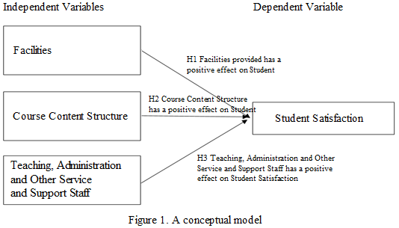

The independent variables are facilities, course content structure and teaching, administration and other service and support staff, Figure 1. While dependent variable would be student satisfaction. Based on Research Questions and Literature Review Theory, the Research have the following three hypotheses.

H1 Facilities provided has a positive effect on Student Satisfaction

H2 Course Content Structure has a positive effect on Student Satisfaction

H3 Teaching, Administration and Other Service and Support Staff has a positive effect on Student

Satisfaction

**6.1 Research Plan**

The plan for this research is the research will collect the data based on the survey as it is part of quantitative method. The question will be asked based on the three factors that has been decided which are facilities provided in KICT, course content structure, and teaching and admin staff, service and support.

The targeted audience will be from Master in Business Intelligence and Analytic program, Master in Protective and Security Management program and KICT undergraduate students as the survey will be distributed from this targeted group. The question will be created from Google form as it is paperless and easy to do some analysis and interpretation via online survey rather than paper survey as we need to transfer those hard copy result into soft copy that could consume a lot of time to deal with the data itself. The survey will be distributed by sending the form through WhatsApp, email and telegram. The survey will use Likert scale when conducting the research as it is commonly involved in research that employs questionnaires. It is the most widely used approach to scaling responses in survey research. The scale will be from one to five and one refer as strongly disagree, two for disagree, three for moderate, four for agree and five for strongly agree. The table in the next chapter shows the example of the survey that will be conducted and distributed among the targeted audience.

**7. INSTRUMENT DEVELOPMENT (SURVEY)**

For this paper, the research was conducted using quantitative survey as our instrument for collecting data. A conceptual model was developed to address the research questions guided by the literature review, Figure 1.

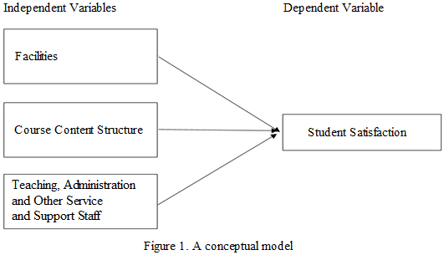

Based on the conceptual model, the independent variables are Facilities, Course Content Structure and Teaching, Administration and Other Service and Support Staff. The dependent variable is Student Satisfaction. The reason for choosing this type of instrument is because it is easy to identify and collect data, based on certain location and time. For this research, the researchers agreed that survey is the most reliable for conducting this research due to wanting to collect the data from the KICT students itself. The other reason that need to be highlighted is there are no data collection by IIUM specifically from KICT faculty. In fact, the students from various faculties in IIUM had filled the compulsory Students Feedback Survey (SFS IIUM) at the end of the semester to collect data to measure the satisfaction level among IIUM. Otherwise, they might not able to do some online pre-registered subject for the next semester. However, we cannot have accessed to the data that was collected and gathered by IIUM due to some restriction and limitation. Hence, we conduct our own research based on survey and analyse what will be good to determine the satisfaction level among KICT students. The questions of the survey that will be conducted will be simpler compared to SFS IIUM as that survey covered all the facilities around IIUM. Therefore, the research which is very much smaller and specific within the KICT faculty and the targeted respondents will be among KICT students will be covered only based on three factors, as our independent variable which are facilities, course content structure and teaching, administration and other service and support staff. The outcome or the dependent variable will be KICT satisfaction level of KICT students.

The question will be asked based on the three factors that has been decided which are facilities provided in KICT, course content structure, and teaching, administration and other service and support staff. The questions that will be asked have fifteen items and will be divided into four part which are introduction, part A for facilities question, part B for Course content structure and part C for teaching, administration and other service and support staff. The questions will be asked are Undergraduate or Postgraduate, Age, Country as IIUM is an international university that has students all around the world, gender, WIFI, Classroom condition, Toilet condition, library condition, workspace condition, subject has enough hands on, course is up to date, course is industry relevant, admin is responsive, support staff is timely and the academic staffs has established good rapport with students.

The question also will ask about the respondent information such as study level whether the respondent is undergraduate or postgraduate students, age, country and gender. Those questions are important so that we can analyse the sentiment of dissatisfaction among KICT students that come from which group. The sentiment that we want to analyse is whether the dissatisfaction level is high among undergraduate or postgraduate? At what range of age the dissatisfaction is high? Do the local students or foreigner students have high dissatisfaction level? Do male or female have much complaint about the facilities of the KICT?

Those questions that will be asked can be used as independent variable. It can be used due to those questions that will be asked are the sentiment of the KICT student to show dissatisfaction to KICT faculty. From those data gathered from the question that respondents will answer, the research can conduct a sentiment analysis of KICT students, then the outcome of this sentiment will be collected as KICT satisfaction level among students that will be used as dependent variable.

The targeted audience will be from Master in Business Intelligent and Analytic program, Master in Protective and Security Management program and KICT undergraduate students as the survey will be distributed to this targeted group. The question will be created from Google form as it is paper less and easy to do some analysis and interpretation via online survey rather than paper survey as we need to transfer those hardcopy result into softcopy that could consume a lot of time to deal with the data itself. The survey will be distributed by sending the form through WhatsApp, email and telegram. The survey will use Likert scale when conducting the research as it is commonly involved in research that employs questionnaires. It is the most widely used approach to scaling responses in survey research. The scale will be from one to five and one refer as strongly disagree, two for disagree, three for moderate, four for agree and five for strongly agree. The table in the next chapter shows the example of the survey that will be conducted and distributed among the targeted audience.

The below figure showed the example of the survey format and question that were distributed among the targeted KICT students. The questions that will be asked have fifteen items and will be divided into four part which are introduction, part A for facilities question, part B for Course content structure and part C for teaching and admin staff, service and support. The question will be asked are Undergraduate or Postgraduate, Age, Country as IIUM is an international university that has students all around the world, gender, WIFI, Classroom condition, Toilet condition, library condition, workspace condition, subject has enough hands on, course is up to date, course is industry relevant, admin is responsive, support staff is timely and the academic staffs has established good support with students.

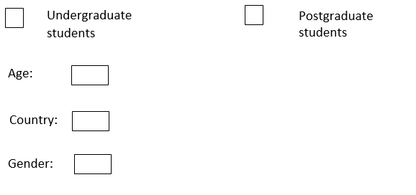INTRODUCTION

Please tick and fill in the relevant information

PART A: FACILITIES

Please tick the relevant information

1- Extremely Bad

2- Bad

3- Moderate

4- Good

5- Excellent

|  |  |  |  |  |  |  |
| --- | --- | --- | --- | --- | --- | --- |
| No | Items | 1 | 2 | 3 | 4 | 5 |
| 1 | WIFI |  |  |  |  |  |
| 2 | Classroom condition |  |  |  |  |  |
| 3 | Toilet condition |  |  |  |  |  |
| 4 | Library |  |  |  |  |  |
| 5 | Workspace |  |  |  |  |  |

PART B: COURSE CONTENT STRUCTURE

Please tick the relevant information

1- Strongly disagree

2- Disagree

3- Moderate

4- Agree

5- Strongly agree

|  |  |  |  |  |  |  |
| --- | --- | --- | --- | --- | --- | --- |
| No | Items | 1 | 2 | 3 | 4 | 5 |
| 1 | Subject has enough hands on |  |  |  |  |  |
| 2 | Course is up to date |  |  |  |  |  |
| 3 | Course is industry relevant |  |  |  |  |  |

PART C: TEACHING, ADMINISTRATION AND OTHER SERVICES AND SUPPORT STAFF

Please tick the relevant information

1- Strongly disagree

2- Disagree

3- Moderate

4- Agree

5- Strongly agree

|  |  |  |  |  |  |  |
| --- | --- | --- | --- | --- | --- | --- |
| No | Items | 1 | 2 | 3 | 4 | 5 |
| 1 | Administrator is responsive |  |  |  |  |  |
| 2 | Support staff is timely |  |  |  |  |  |
| 3 | Academic staffs have established good support with students |  |  |  |  |  |

**8. DATA COLLECTION PROCEDURES**

As a survey conducted is to collect data about the people, thought and behaviour in systematic and academic manner, it is very useful to learn about something that has been proposed for to the targeted population. The other reason of using the survey to collect the data so that it manages to capture a fleeting moment in time. Another word, it is a snapshot for certain time or period when conducting some research.

The unit of analysis for this research conducted will be taken from a group of crowd or respondents which are KICT students. Then after determination of the unit of analysis, the set of questionnaire will be drafted to test the hypothesis between the independent variable and dependent variable. Before distributed those questions, pre-testing and pilot study will be conducted from a group of researchers, lecturers and supervisors. The survey distributed will be on targeted sampling from KICT students. The targeted survey will be distributed is 50 respondents and the targeted respondents of the appropriate respond rate will be 30 people.

The data requirement for this research will be based on the three factors or independent variables which are facilities of the faculty, course content structure and teaching, administration and other service and support staff. Based on the data requirement that has been addressed, the data generation will be questionnaires provided by doing survey. The sampling frame or in another word a list or collection of the whole population of people that could be included in the survey is among the classmates, and random KICT students that have enrolled for this faculty. The sampling technique will be probabilistic technique called stratified sampling. Stratified sampling techniques were applied, as there were identifiable subgroups of MBIA, MPSM and KICT Undergraduates students.

The selection of methods for questionnaire distribution will be using WhatsApp online chat. The survey will be sent through the people of KICT students by getting their number from administrator staffs. The main challenge for this art is to get good response rate. In order to get high response rate, the timing when distributing the survey will be considered as the question will be sent after working hours so that they could have time to answer the question. Make the good impression as by greeting them with salam, explain the outcome for this research and also addressing that their contribution will help others when the research is done. Offering the results of our study to the respondents to clarify to them that their contribution is worthy to complete the study.

**9. STATISTICAL ANALYSIS**

This study employs statistical methods of descriptive analyses, independent *t*-test and the analysis of variance (ANOVA). Descriptive analysis is conducted to understand the general level of student satisfaction in KICT. The independent *t*-test and ANOVA are used to examine the relationship between demographic factors and student satisfaction. Furthermore, multiple linear regression analysis aimed at finding out about the factors influencing student satisfaction.

This research will use Pearson Correlation and Regression Analysis. The data analysis for this study is conducted through R Studio. The study also will test reliability of the instrument so that it enables to produce a robust and valid result. Pearson correlation is used to test the hypotheses of the research and to identify the direction of the relationship between the variable and the significance of the relationship. The value of Pearson correlation is range between -1 and +1. + 1 represents perfect positive relationship between the variables. -1 represents perfect negative relationship. Validity and reliability tests were conducted to ensure face, content and construct validity and reliability of variable measures. Reliability analysis is used to find the internal consistency between the items of the scales based on Cronbach’s Alpha. The more Cronbach’s Alpha close to 1, the more reliable is the measurements. The value of Cronbach’s Alpha is greater than 0.6, the internal consistency is weak. 0.7 or greater is considered acceptable. 0.8 or greater is considered good.

In the context of business intelligence and big data analytic, statistical analysis is very important by collecting and scrutinizing every data sample that has been taken and collected. The sample collected in statistics is a representative selection drawn from a total population. As the goal of statistical analysis is to identify trends and study the sentiment analysis of the research in KICT satisfaction among students, it might use statistical analysis to find patterns as in this research from structured data that has been collected that can be used to create a more positive feedback from the students and increase satisfaction level among KICT students.

The tool that will be used to analyse the data is R studio tool as it is a tool and programming language for statistical computing and graphic for data visualization. It can change the number into interactive graphic that might help to understand better when dealing with a lot of data collection.

Hypothesis testing is a method that assesses if a certain premise is actually true for the data set or population. It might be useful for testing the hypothesis that is created if the result could not have happened by random change. The hypotheses testing is also known as t-testing.

**10. RESULTS**

As mentioned in the previous section of statistical analysis, the research conducted, based on descriptive analysis which produced the result of maximum data, minimum data, median of the data, and mean of the data. This research also conducted a standard deviation method to test how measurements for a group are spread out from the average (mean), or expected value. A low standard deviationmeans that most of the numbers are very close to the average. A high standard deviation means that the numbers are spread out.

When the survey has been collected from 30 respondents, the data collected has been changed into csv format. Then the data was imported into R studio. These are the table of the data from R studio view:

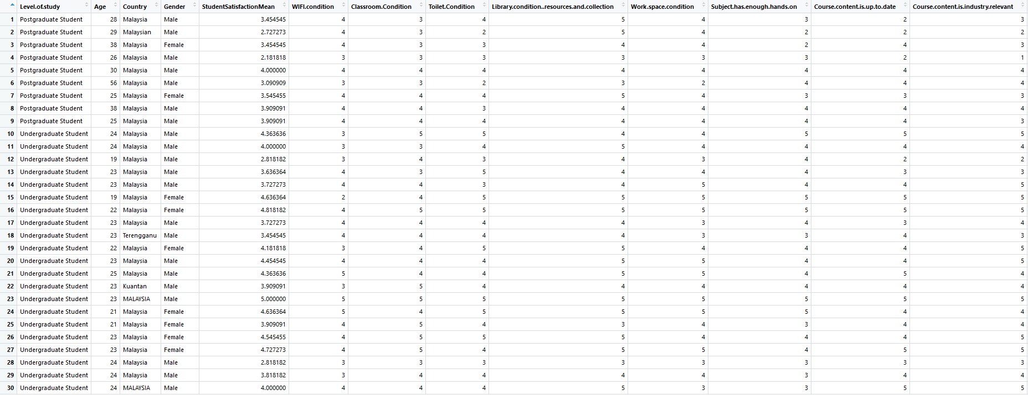

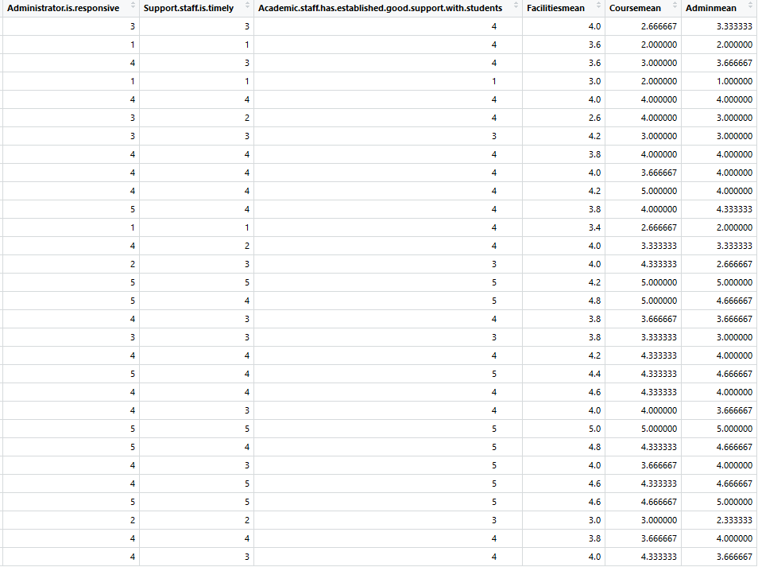

We did descriptive analysis by analysing maximum value, minimum value, mean, median of the dataset.

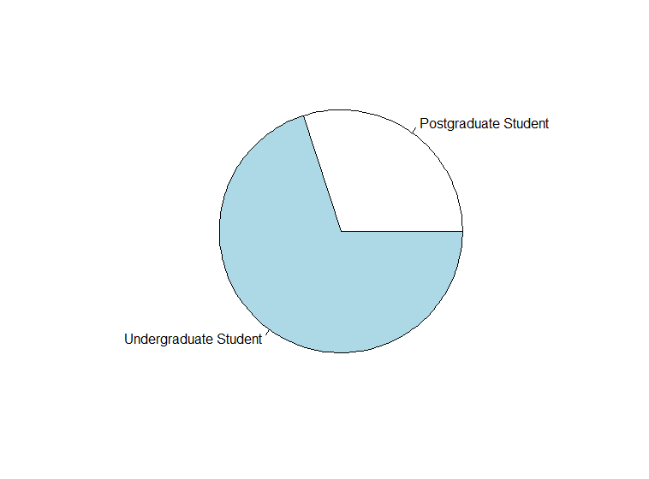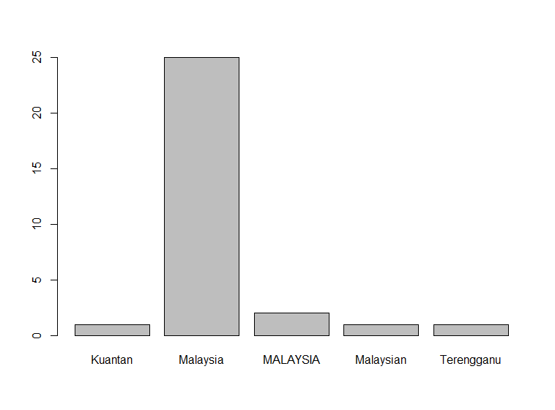

Based on the graph above on the left, it is noticeable that most of the respondents are from undergraduate students compared to postgraduate students. From the above graph on the right, the country variable data result is inconsistence and illogical hence will not be able to perform analysis by Country. Some respondents do not declare their country of origin.

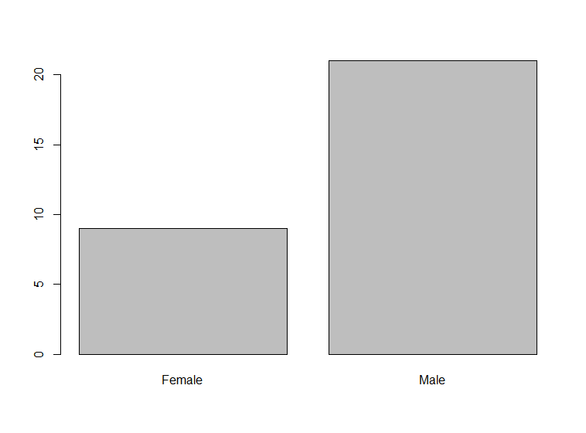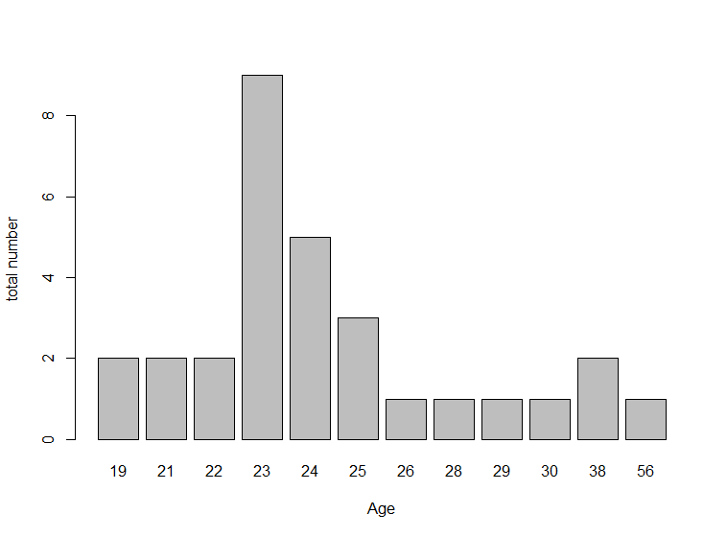

From the above graphs, most of the respondents are male and most number of respondents is 23 years old.

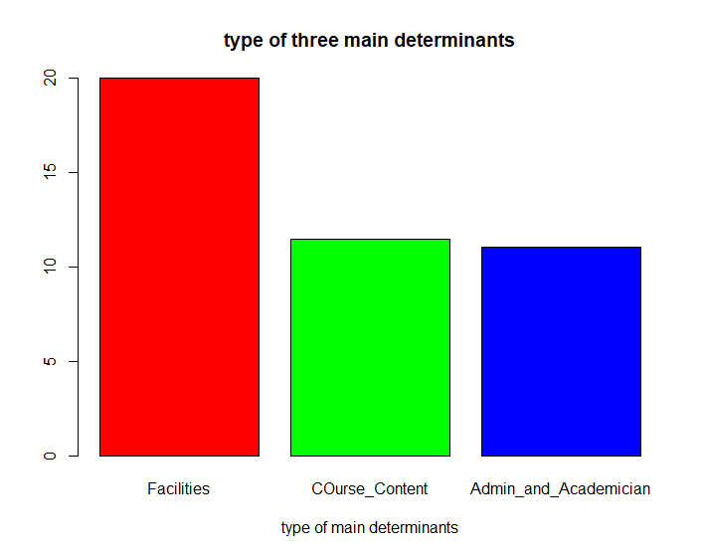

The above shows the differences between three major determinants which are facilities, course content structure and admin and academic staff. From the graph it is clear that facilities variable has highest value(most satisfied) while lowest value is admin and academician variable(least satisfied).



From the figure above, it shows that type of variable from all three major determinants. Library condition received the highest value (most satisfied) while administrative support is the minimum value among eleven variables that has been tested.

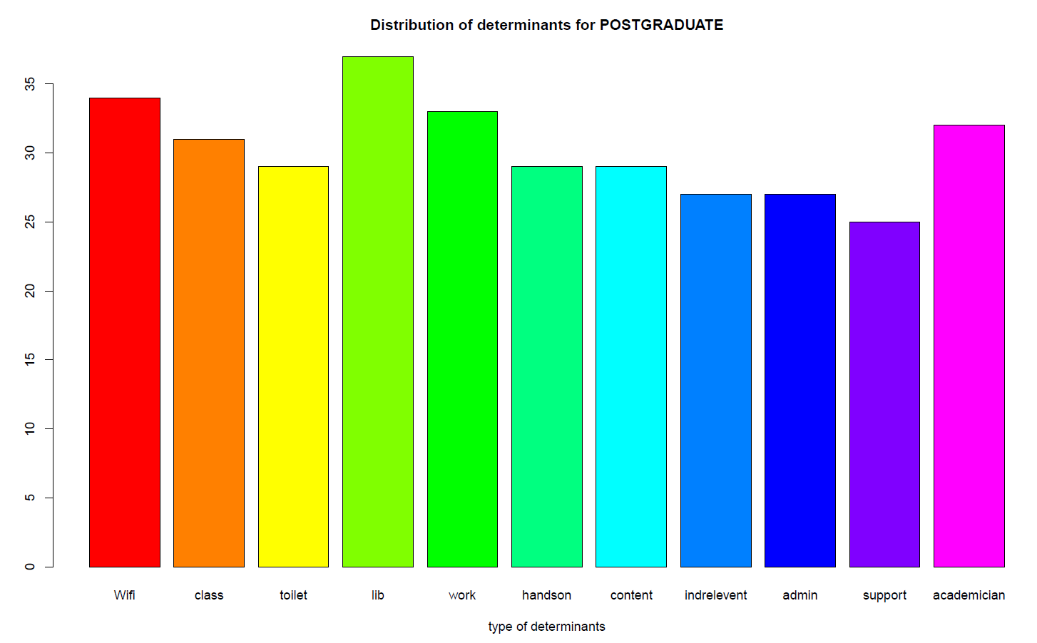

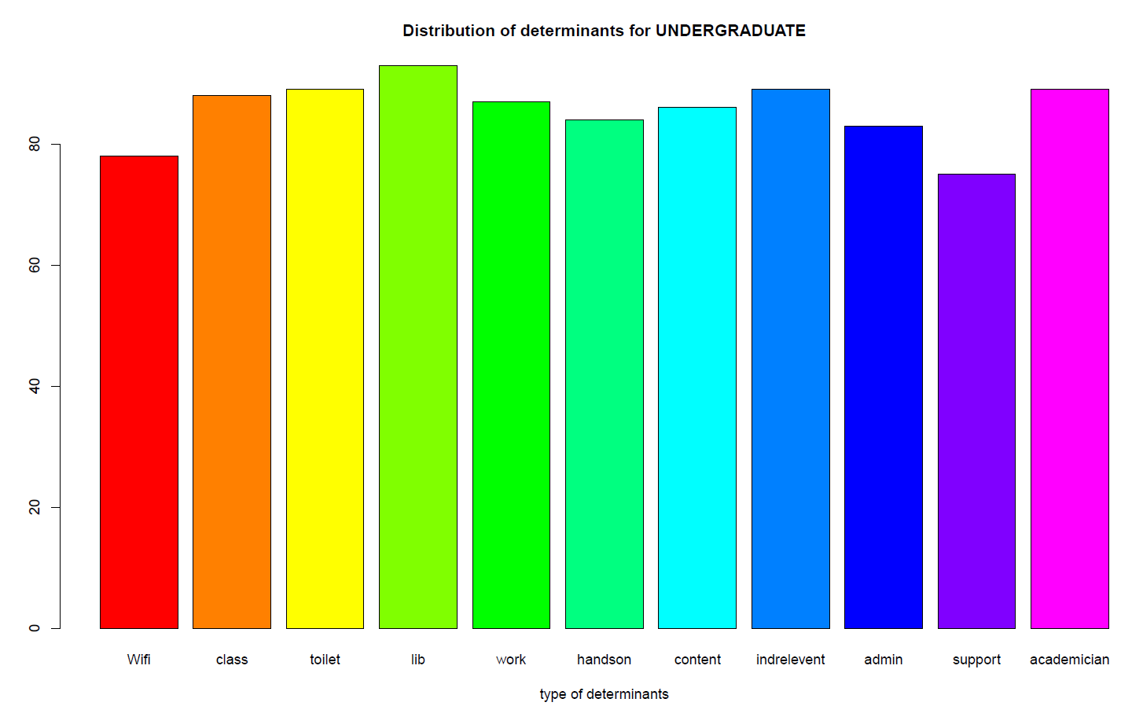

Then we separated the table into postgraduate and undergraduate to study the comparison among postgraduate student and undergraduate student. It is shown that library has the highest value for both postgraduate and undergraduate and the lowest value for the variables is administrative support variable for both as well.

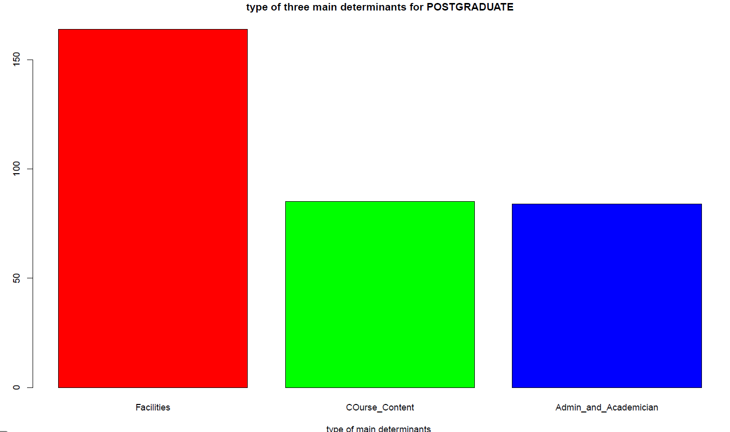 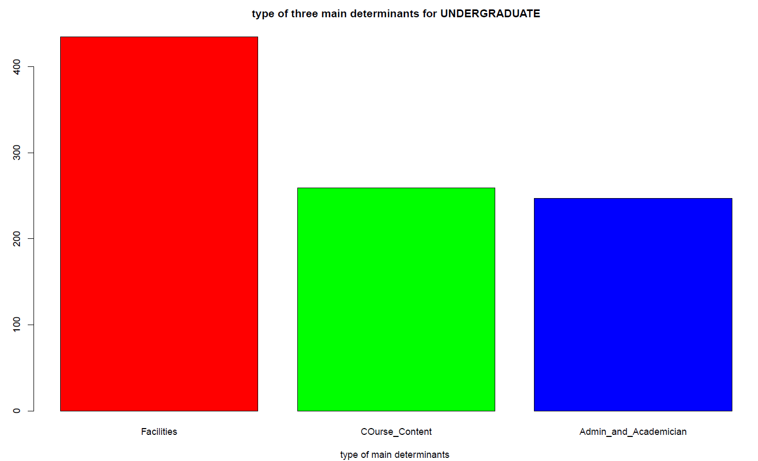

From the above, the graph has been constructed to categorize the variable into three major determinants by course level. The highest value is facilities variable is the maximum variable for both postgraduate and undergraduate, while admin and academician is the lowest value for both level of study.

This is the result for **standard deviation, mean and median** for all eleven variables

|  |  |  |  |
| --- | --- | --- | --- |
|  | Standard deviation | mean | median |
| Age | 7.187873 | 25.7 | 23.5 |
| WIFI CONDITION | 0.6914918 | 3.733333 | 4 |
| CLASSROOM CONDITION | 0.7183954 | 3.966667 | 4 |
| TOILET CONDITION | 0.868345 | 3.933333 | 4 |
| LIBRARY CONDITION | 0.711159 | 4.333333 | 4 |
| WORKSPACE CONDITION | 0.7878386 | 4 | 4 |
| SUBJECT HAS ENOUGH HANDS ON | 0.8172002 | 3.766667 | 4 |
| COURSE CONTENT IS UP TO DATE | 0.9498941 | 3.833333 | 4 |
| COURSE CONTENT IS INDUSTRY RELEVANT | 1.074255 | 3.866667 | 4 |
| ADMINISTRATIVE IS RESPONSIVE | 1.212957 | 3.666667 | 4 |
| SUPPORT STAFF TIMELY | 1.154701 | 3.333333 | 3.5 |
| ACADEMIC STAFF GOOD SUPPORT | 0.8502873 | 4.033333 | 4 |

The descriptive analysis from another perspective follows. Table 1 represents the descriptive statistics for student satisfaction of students of KICT, IIUM by Gender.

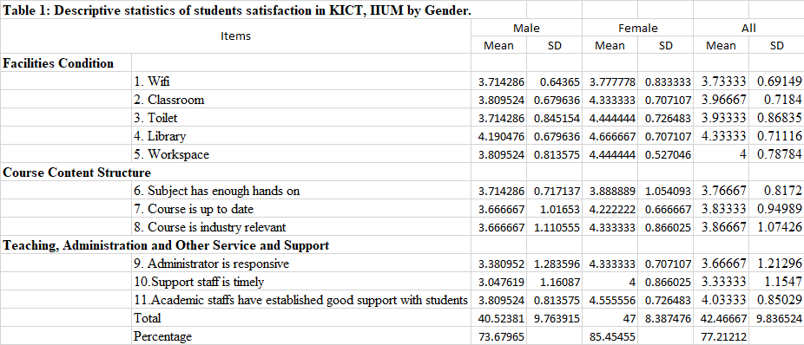

The satisfaction level of the students was 77.21%. The satisfaction level of male students is lower (73.68%) than female (85.45%). The value of standard deviation ranged from 0.64 to 1.28 for male and 0.53 to 1.05 for female. Overall, the value of standard deviation varied from 0.69 to 1.21.

Male students were most satisfied with ‘Library’ (4.19), followed by the factors ‘Classroom’ (3.81), and ‘Academic staffs have established good support with students’ (3.81). Female students were most satisfied with ‘Library’ (4.67), followed by the ‘Academic staffs have established good support with students’ (4.56), ‘Toilet’ and ‘Workspace’ (4.44). Male students were least satisfied with ‘Support staff is timely’ (3.05); followed by the factors ‘Administrator is responsive’ (3.38) as well as ‘Course is up to date’ and ‘Course is industry relevant’ (3.67).

Female students were least satisfied with ‘Wifi’ (3.78); followed by ‘Subject has enough hands on’ (3.89) and ‘Course is up to date’ (4.22). Overall, the most influential factor on students satisfaction were ‘Library’ (4.33), followed by the satisfaction level in terms of ‘Academic staffs have established good support with students’ (4.03), ‘Classroom’ (3.97). The students were least satisfied with ‘Support staff is timely’ (3.33), followed by the ‘Administrator staff is responsive’ (3.67), ‘Wifi’ (3.73).

Table 2 represents the descriptive statistics for student satisfaction of students of KICT, IIUM by Course Level.

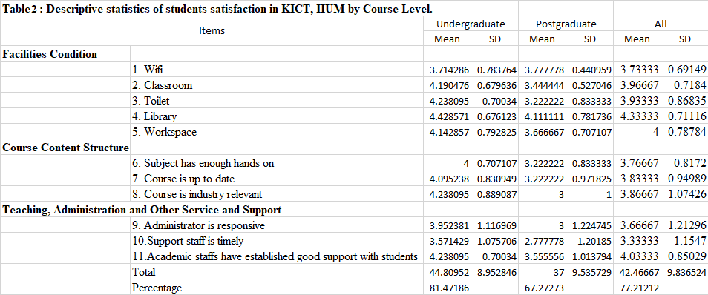

The satisfaction level of the students was 77.21%. The satisfaction level of Undergraduate students is lower (81.47%) than Postgraduate (67.27%). The value of standard deviation ranged from 0.68 to 1.12 for Undergraduate and 0.44 to 1.22 for Postgraduate. Overall, the value of standard deviation varied from 0.69 to 1.21.

Undergraduate students were most satisfied with ‘Library’ (4.43), followed by the factors ‘Toilet’, ‘Course is industry relevant’ and ‘Academic staffs have established good support with students’ (4.03). Postgraduate students were most satisfied with ‘Library’ (4.11), followed by the ‘Wifi’ (3.78), ‘Academic staffs have established good support with students’ (3.56), and ‘Classroom’ (3.44). Undergraduate students were least satisfied with ‘Support staff is timely’ (3.57); followed by the factors ‘Wifi’ (3.71) and ‘Administrator is responsive’ (3.95).

Postgraduate students were least satisfied with ‘Support staff is timely’ (2.78),‘Wifi’ (3.78); followed by ‘Toilet’, ‘Subject has enough hands on’and ‘Course is up to date’ (3.22). Overall, the most influential factor on students satisfaction were ‘Library’ (4.33), followed by the satisfaction level in terms of ‘Academic staffs have established good support with students’ (4.03), ‘Classroom’ (3.97). The students were least satisfied with ‘Support staff is timely’ (3.33), followed by the ‘Administrator staff is responsive’ (3.67), ‘Wifi’ (3.73).

Before we run inference statistics, we did a Reliability analysis. It is used to find the internal consistency between the items of the scales based on Cronbach’s Alpha. The results of the reliability analysis on eleven variables collected from the survey have standard alpha ranges between 0.93 to 0.95 which suggest a very good internal consistency.

alpha(studentsmean)

Reliability analysis

Call: alpha(x = studentsmean)

raw_alpha std.alpha G6(smc) average_r S/N ase mean sd median_r

0.92 0.91 0.94 0.49 11 0.019 3.9 0.68 0.51

lower alpha upper 95% confidence boundaries

0.88 0.92 0.96

Reliability if an item is dropped:

raw_alpha std.alpha G6(smc) average_r S/N alpha se var.r med.r

WIFI.condition 0.93 0.93 0.95 0.56 12.5 0.018 0.019 0.54

Classroom.Condition 0.91 0.91 0.93 0.49 9.8 0.021 0.041 0.51

Toilet.Condition 0.91 0.90 0.93 0.48 9.4 0.021 0.040 0.51

Library.condition..resources.and.collection 0.92 0.91 0.94 0.51 10.3 0.020 0.040 0.53

Work.space.condition 0.91 0.91 0.94 0.49 9.5 0.021 0.044 0.52

Subject.has.enough.hands.on 0.91 0.91 0.94 0.50 10.0 0.020 0.038 0.51

Course.content.is.up.to.date 0.91 0.90 0.93 0.48 9.2 0.022 0.035 0.51

Course.content.is.industry.relevant 0.90 0.90 0.93 0.47 8.9 0.023 0.034 0.50

Administrator.is.responsive 0.90 0.90 0.92 0.47 8.7 0.024 0.035 0.50

Support.staff.is.timely 0.90 0.90 0.93 0.46 8.5 0.025 0.034 0.49

Academic.staff.has.established.good.support.with.students 0.91 0.90 0.93 0.48 9.4 0.021 0.042 0.51

Item statistics

n raw.r std.r r.cor r.drop mean sd

WIFI.condition 30 0.33 0.37 0.28 0.24 3.7 0.69

Classroom.Condition 30 0.69 0.71 0.68 0.64 4.0 0.72

Toilet.Condition 30 0.76 0.77 0.75 0.71 3.9 0.87

Library.condition..resources.and.collection 30 0.61 0.63 0.60 0.54 4.3 0.71

Work.space.condition 30 0.72 0.75 0.71 0.67 4.0 0.79

Subject.has.enough.hands.on 30 0.68 0.68 0.64 0.62 3.8 0.82

Course.content.is.up.to.date 30 0.81 0.79 0.79 0.76 3.8 0.95

Course.content.is.industry.relevant 30 0.86 0.84 0.84 0.81 3.9 1.07

Administrator.is.responsive 30 0.89 0.86 0.87 0.84 3.7 1.21

Support.staff.is.timely 30 0.91 0.90 0.91 0.88 3.3 1.15

Academic.staff.has.established.good.support.with.students 30 0.77 0.77 0.75 0.71 4.0 0.85

Non missing response frequency for each item

1 2 3 4 5 miss

WIFI.condition 0.00 0.03 0.30 0.57 0.10 0

Classroom.Condition 0.00 0.00 0.27 0.50 0.23 0

Toilet.Condition 0.00 0.07 0.20 0.47 0.27 0

Library.condition..resources.and.collection 0.00 0.00 0.13 0.40 0.47 0

Work.space.condition 0.00 0.03 0.20 0.50 0.27 0

Subject.has.enough.hands.on 0.00 0.07 0.27 0.50 0.17 0

Course.content.is.up.to.date 0.00 0.13 0.13 0.50 0.23 0

Course.content.is.industry.relevant 0.03 0.07 0.23 0.33 0.33 0

Administrator.is.responsive 0.10 0.07 0.13 0.47 0.23 0

Support.staff.is.timely 0.10 0.10 0.30 0.37 0.13 0

Academic.staff.has.established.good.support.with.students 0.03 0.00 0.13 0.57 0.27 0

The research then analysed the data based on analysis of variance (ANOVA). ANOVA method are used to examine the relationship between demographic factor of student satisfaction level. The factors or determinants of this research that resulted the student satisfaction level are facilities, course content structure and teaching, administration and other services and support staff.

By using ANOVA method in R, these are the result for studentsatisfactionmean and gender.

aov(KICT.Satisfaction.level$StudentSatisfactionMean ~ KICT.Satisfaction.level$Gender)

Call:

aov(formula = KICT.Satisfaction.level$StudentSatisfactionMean ~

KICT.Satisfaction.level$Gender)

Terms:

KICT.Satisfaction.level$Gender Residuals

Sum of Squares 2.183707 11.035026

Deg. of Freedom 1 28

Residual standard error: 0.6277803

Estimated effects may be unbalanced

This is the ANOVA summary result for studentsatisfactionmean and gender

ANOVAgender <-aov(KICT.Satisfaction.level$StudentSatisfactionMean ~ KICT.Satisfaction.level$Gender)

> summary(ANOVAgender)

Df Sum Sq Mean Sq F value Pr(>F)

KICT.Satisfaction.level$Gender 1 2.184 2.1837 5.541 0.0258 *

Residuals 28 11.035 0.3941

---

Signif. codes: 0 ‘***’ 0.001 ‘**’ 0.01 ‘*’ 0.05 ‘.’ 0.1 ‘ ’ 1

This is the ANOVA result for studentsatisfactionmean and level of study

aov(KICT.Satisfaction.level$StudentSatisfactionMean ~ KICT.Satisfaction.level$Level.of.study)

Call:

aov(formula = KICT.Satisfaction.level$StudentSatisfactionMean ~

KICT.Satisfaction.level$Level.of.study)

Terms:

KICT.Satisfaction.level$Level.of.study Residuals

Sum of Squares 3.175443 10.043290

Deg. of Freedom 1 28

Residual standard error: 0.5989064

Estimated effects may be unbalanced

This is the ANOVA summary result for studentsatisfactionmean and level of study

ANOVAlevelstudy <- aov(KICT.Satisfaction.level$StudentSatisfactionMean ~ KICT.Satisfaction.level$Level.of.study)

> summary(ANOVAlevelstudy)

Df Sum Sq Mean Sq F value Pr(>F)

KICT.Satisfaction.level$Level.of.study 1 3.175 3.175 8.853 0.00597 **

Residuals 28 10.043 0.359

---

Signif. codes: 0 ‘***’ 0.001 ‘**’ 0.01 ‘*’ 0.05 ‘.’ 0.1 ‘ ’ 1

From another perspective, Table 3 represents the result of one way ANOVA analysis by gender. The result showed that, p-value was 8.36E-05. Therefore, the students satisfaction result is statistically significant (p<0.05) which means satisfaction level contrast between male and female.

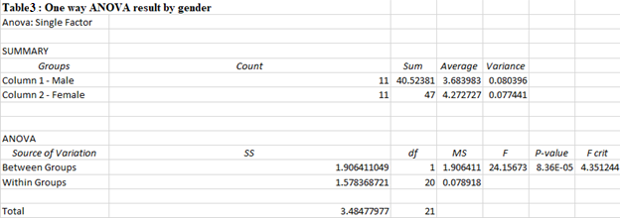

Table 4 represents the result of one way ANOVA analysis by Course Level. The result showed that, p-value was 5.91E-05. Therefore, the students satisfaction result is statistically significant (p<0.05) which means satisfaction level contrast between Undergraduate and postgraduate students.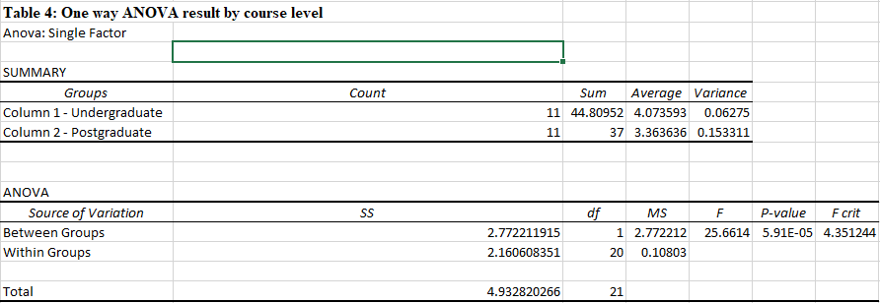 The function of t test is to examine the relationship between demographic factor of student satisfaction level. Since the data that has been collected has eleven variables that has not been grouped into three major determinants, hence we decided to add three more columns to differentiate between the eleven variables provided in dataset to sum of the variables into specific column of dataset. For the faculties variable it contains five variables which are WIFI condition, classroom condition, toilet condition, library condition and work space condition. We sum up all the variable for faculties determinant and put those result in one column called partA. For the course content structure determinants consist of subject has enough hands on variable, course content is up to date variable and course content is industry relevant variable. We sum up those three variable and put those result into partB column. For the teaching, administration and other services and support staff determinants consist of three variables which are administrative is responsive variable, support staff timely variable and academic staffs establish good support with students variable and sum up all the three variable and store it in one column called partC. Below is the figure to make more understandable:

* WIFI,
* Classroom,
* Toilet,
* Library,
* workspace conditons

Facilities

(partA)

Course content structure

(partB)

* subject has enough hands on, course
* content is up to date
* course content is industry relevant variable

Teaching and Admin staff

(partC)

* administrative is responsive,
* support staff timely variable
* academic staffs establish good support with students

From those table that contains facilitiesmean, coursemean and adminmean, we manage to calculate the cor test based on three major determinants. Those are the result that we managed to analyse.

The data below showed the cor test that has been compared with facilitiesmean and coursemean:

cor.test(KICT.Satisfaction.level$partA, KICT.Satisfaction.level$partB, method=c("pearson", "kendall", "spearman"))

Pearson's product-moment correlation

data: KICT.Satisfaction.level$partA and KICT.Satisfaction.level$partB

t = 4.5068, df = 28, p-value = 0.0001067

alternative hypothesis: true correlation is not equal to 0

95 percent confidence interval:

0.3759514 0.8176635

sample estimates:

cor

0.6483991

The **p-value** of the test is 0.0001067, which is less than the significance level alpha = 0.05. We can conclude that Facilities and Course Content Structure are significantly correlated with a correlation coefficient of 0.6483991 and p-value of 0.0001067.

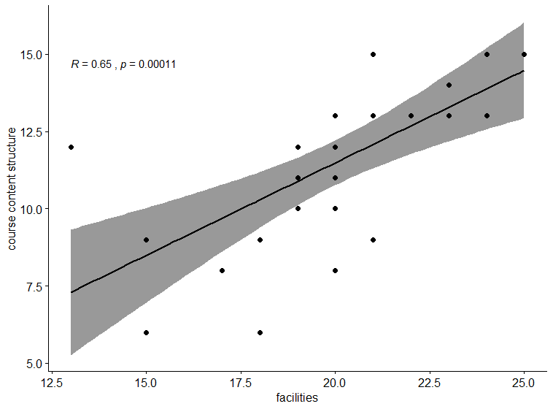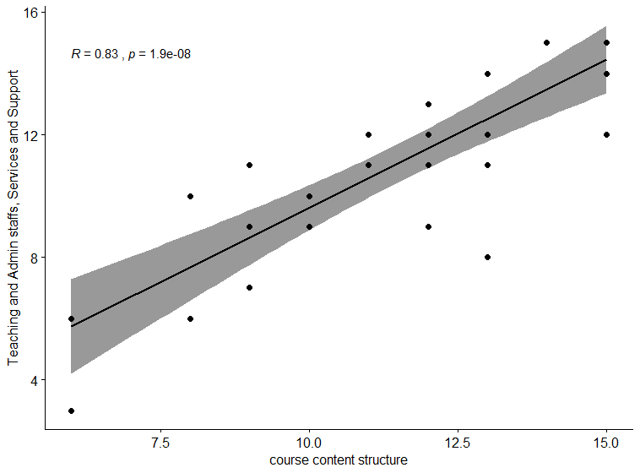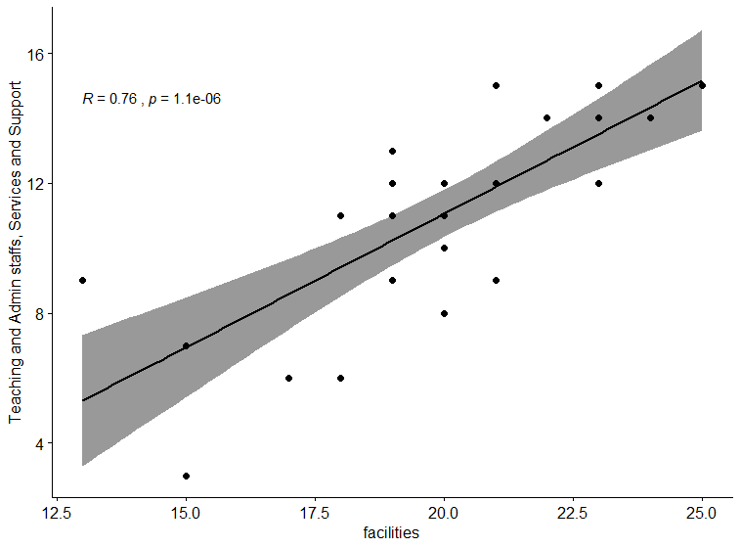

figure for facilities and admin graph cor test

Figure for course and admin graph cor test

Table for facilities and course cor test graph

The data below showed the cor test that has been compared with course and admin:

cor.test(KICT.Satisfaction.level$partB, KICT.Satisfaction.level$partC, method=c("pearson", "kendall", "spearman"))

Pearson's product-moment correlation

data: KICT.Satisfaction.level$partB and KICT.Satisfaction.level$partC

t = 7.7491, df = 28, p-value = 1.928e-08

alternative hypothesis: true correlation is not equal to 0

95 percent confidence interval:

0.6627396 0.9141270

sample estimates:

cor

0.8258298

The **p-value** of the test is 1.928e-08, which is less than the significance level

alpha = 0.05. We can conclude that Course Content Structure and Teaching, Administration, and other Service and Support are significantly correlated with a correlation coefficient of 0.8258298

and p-value of 1.928e-08.

The data below showed the cor test that has been compared with facilities and admin:

cor.test(KICT.Satisfaction.level$partA, KICT.Satisfaction.level$partC, method=c("pearson", "kendall", "spearman"))

Pearson's product-moment correlation

data: KICT.Satisfaction.level$partA and KICT.Satisfaction.level$partC

t = 6.1904, df = 28, p-value = 1.098e-06

alternative hypothesis: true correlation is not equal to 0

95 percent confidence interval:

0.5506784 0.8795429

sample estimates:

cor

0.7601413

The **p-value** of the test is 1.098e-06, which is less than the significance level alpha = 0.05. We can conclude that Facilities and Teaching, Administration, and other Service and Support are significantly correlated with a correlation coefficient of 0.7601413 and p-value of 1.098e-06.

From the result above cor test correlation value between partA and partB is 0.6483991,

while cor test correlation value between partA and partC is 0.8258298 and the cor test correlation value between partA and partC

is 0.7601413.

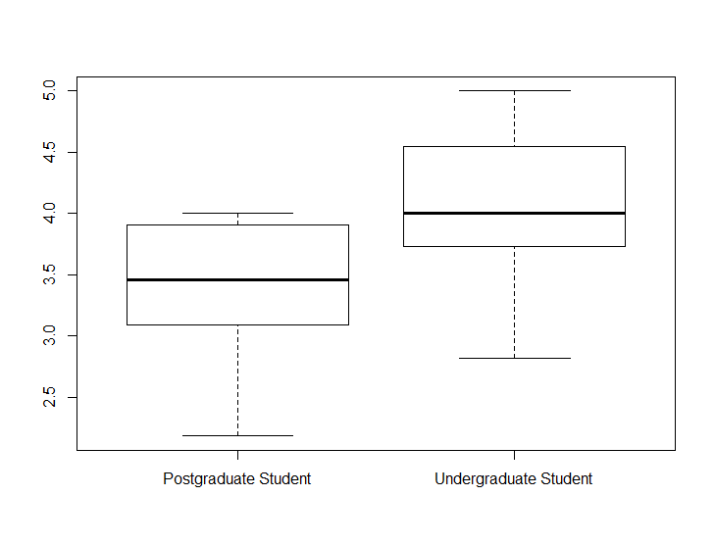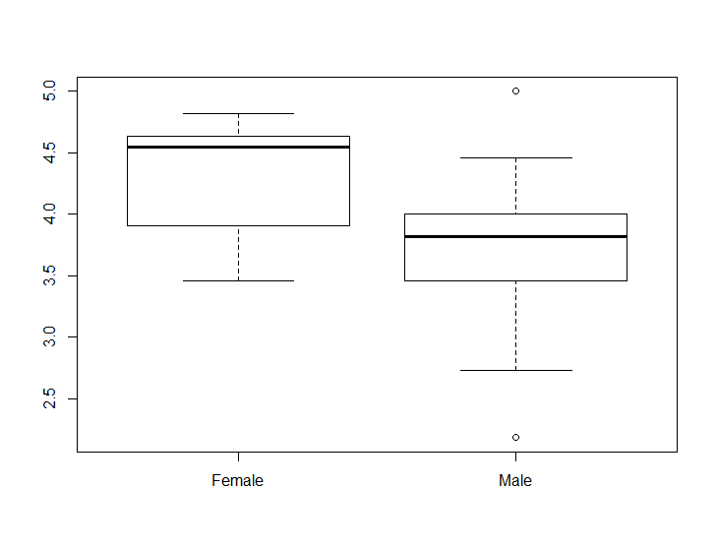

Comparison between gender and studentsatisfaction by mean

Comparison between level of study and studentsatisfaction by mean

We proceeded to test the result using cor test to know if there is a strong correlation between the main determinants and the students satisfaction by correlating the mean of the determinants and the students satisfaction mean.

cor.test(KICT.Satisfaction.level$Facilitiesmean, KICT.Satisfaction.level$StudentSatisfactionMean, method=c("pearson", "kendall", "spearman"))

Pearson's product-moment correlation

data: KICT.Satisfaction.level$Facilitiesmean and KICT.Satisfaction.level$StudentSatisfactionMean

t = 9.9646, df = 28, p-value = 1.041e-10

alternative hypothesis: true correlation is not equal to 0

95 percent confidence interval:

0.7669669 0.9433139

sample estimates:

cor

0.8831962

The **p-value** of the test is 1.041e-10, which is less than the significance level

alpha = 0.05. We can conclude that Facilities and Student Satisfaction are significantly correlated with a correlation coefficient of 0.8831962 and p-value of 1.041e-10.

cor.test(KICT.Satisfaction.level$Coursemean, KICT.Satisfaction.level$StudentSatisfactionMean, method=c("pearson", "kendall", "spearman"))

Pearson's product-moment correlation

data: KICT.Satisfaction.level$Coursemean and KICT.Satisfaction.level$StudentSatisfactionMean

t = 10.878, df = 28, p-value = 1.456e-11

alternative hypothesis: true correlation is not equal to 0

95 percent confidence interval:

0.7972658 0.9513159

sample estimates:

cor

0.8992447

The **p-value** of the test is 1.456e-11, which is less than the significance level

alpha = 0.05. We can conclude that Course Content Structure and Student Satisfaction are significantly correlated with a correlation coefficient of -0.8992447 and p-value of 1.456e-11.

cor.test(KICT.Satisfaction.level$Adminmean, KICT.Satisfaction.level$StudentSatisfactionMean, method=c("pearson", "kendall", "spearman"))

Pearson's product-moment correlation

data: KICT.Satisfaction.level$Adminmean and KICT.Satisfaction.level$StudentSatisfactionMean

t = 16.111, df = 28, p-value = 1.079e-15

alternative hypothesis: true correlation is not equal to 0

95 percent confidence interval:

0.8967346 0.9762029

sample estimates:

cor

0.950069

The **p-value** of the test is 1.079e-15, which is less than the significance level alpha = 0.05. We can conclude that Teaching, Administration, and other Service and Support and Student Satisfaction are significantly correlated with a correlation coefficient of 0.950069 and p-value of 1.079e-15.

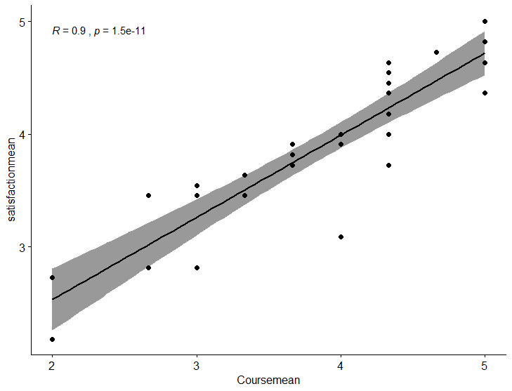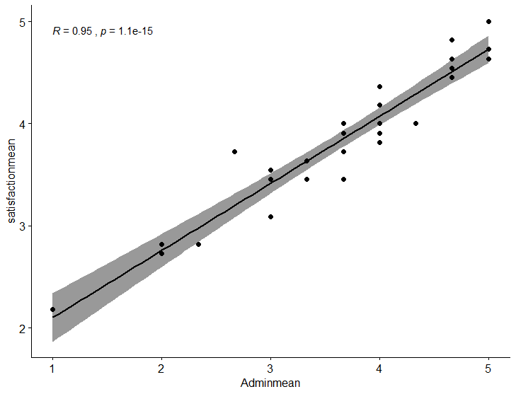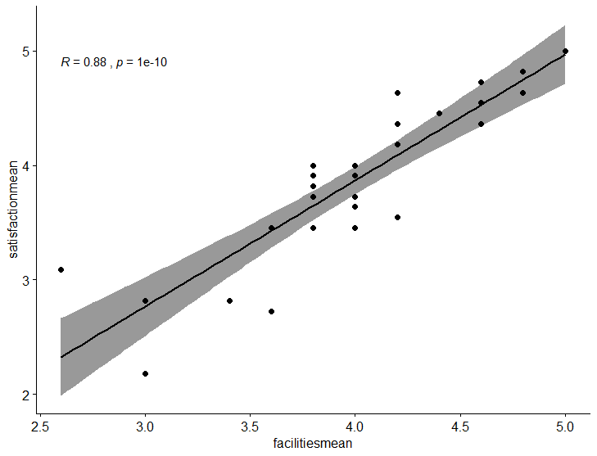

Table for Coursemean and studentsatisfactionmean test graph

Table for Facilitiesmean and studentsatisfactionmean test graph

Table for Adminmean and studentsatisfactionmean test graph

Then we conducted t test by comparing three major determinants and student satisfaction mean. We compare by taking the data from faculty means, course means and student satisfaction means.

**T test for facilities and student satisfaction**

t.test(KICT.Satisfaction.level$Facilitiesmean,KICT.Satisfaction.level$StudentSatisfactionMean)

Welch Two Sample t-test

data: KICT.Satisfaction.level$Facilitiesmean and KICT.Satisfaction.level$StudentSatisfactionMean

t = 0.83968, df = 55.41, p-value = 0.031308564

alternative hypothesis: true difference in means is not equal to 0

95 percent confidence interval:

-0.1839956 0.4494502

sample estimates:

mean of x mean of y

3.993333 3.860606

The **p-value** of the test is 0.031308564, which is less than the significance level alpha = 0.05, we can conclude that Facilities has a positive effect on Student Satisfaction.

**T test for Course content structure and student satisfaction**

> t.test(KICT.Satisfaction.level$Coursemean,KICT.Satisfaction.level$StudentSatisfactionMean)

Welch Two Sample t-test

data: KICT.Satisfaction.level$Coursemean and KICT.Satisfaction.level$StudentSatisfactionMean

t = -0.19595, df = 55.594, p-value = 0.576643876

alternative hypothesis: true difference in means is not equal to 0

95 percent confidence interval:

-0.4308459 0.3540782

sample estimates:

mean of x mean of y

3.822222 3.860606

The **p-value** of the test is 0.576643876, which is greater than the significance level alpha = 0.05, we can conclude that Course Content Structure has no effect on Student Satisfaction.

**T test for Teaching and admin staff and support and student satisfaction**

> t.test(KICT.Satisfaction.level$Adminmean,KICT.Satisfaction.level$StudentSatisfactionMean)

Welch Two Sample t-test

data: KICT.Satisfaction.level$Adminmean and KICT.Satisfaction.level$StudentSatisfactionMean

t = -0.84341, df = 51.563, p-value = 0.017129251

alternative hypothesis: true difference in means is not equal to 0

95 percent confidence interval:

-0.6179025 0.2522459

sample estimates:

mean of x mean of y

3.677778 3.860606

The **p-value** of the test is 0.017129251, which is less than the significance level

alpha = 0.05. We can conclude that Teaching, Administration, and other Service and Support has a positive effect on Student Satisfaction.

**11. DISCUSSION**

This research has provided a snapshot of some of the key determinants of the student satisfaction of KICT, IIUM. Based on the results, the three key determinants are Facilities, Course Content Structure and Teaching, Administration and Other Service and Support Staff. Facilities and Teaching, Administration and Other Service and Support Staff have strong influence on KICT Student Satisfaction. While Course Content Structure surprisingly did not have an influence on KICT Student Satisfaction based on our findings.

This research can assist KICT Faculty administrators and lecturers in their quality assurance initiatives which may include reviewing the current system, setting faculty priorities, and planning and allocation of future resources to better achieve higher levels of student satisfaction.

This study investigated the satisfaction level of students of KICT, IIUM and compared it with respect to gender difference and course levels enrolled. The KICT students were 77.21% satisfied and the satisfaction level is affected by gender difference. Male KICT students were less satisfied, 73.68%, compared to female students, 85.45%. KICT students satisfaction level is very different by course levels enrolled. Undergraduate KICT students were very much satisfied, 81.47%, compared to Postgraduate students, 67.27%. This would suggest that Female Undergraduate KICT students are most satisfied, and Male Postgraduate KICT students are least satisfied.

Support Staff Timeliness and Administrator responsiveness are the two least satisfied items surveyed. Teaching, Administration and Other Service and Support should be prioritised as it is the least satisfaction factor among students. It is important to treat and respect KICT Students as Customers. Effort should be instilled to provide better timeliness and responsiveness Customer Service culture.

Good customer service means helping customers responsively, in a timely manner. It is essential to be able to handle issues for customers and to do your best to ensure they are satisfied. Providing good service is one of the most important things that can differentiate KICT and set a tradition for others.

Finally, by taking into consideration of this study, the KICT, IIUM authority, staff and lecturers should pay particular attention to improve the Customer Service, coming from Teaching, Administration and Other Service and Support, to complement the Facilities and Course Content Structure, ensuring quality education. The KICT faculty Staff and Lecturers can focus on the targeted findings and manage Male Postgraduate KICT students better while continuing to improve Customers Services to Female Undergraduate KICT Students.

This study included some limitations where only student-reported data and did not include staff-reported data as well. Another limitation of this study comes from local KICT students and have no International students. This research provided findings toward students stated opinions and experiences from KICT, IIUM where they are learning, targeting their level of satisfaction from the services and staff of KICT, IIUM. KICT Students reported high level of satisfaction from the facilities, course content and structure and customer support from KICT, IIUM. All this findings can help the authorities and policy makers for the improvement of the quality in KICT, considering that such areas are vital for the students’ life in KICT, IIUM.

**12. REFERENCES**

Arambewela, R., & Hall, J. (2009). An empirical model of international student satisfaction. *Asia Pacific Journal of Marketing and Logistics*, 21(4), 555-569, <https://doi.org/10.1108/13555850910997599>

Banwet, D.K., & Datta, B. (2003). A study of the ef­fect of perceived lecture quality on post- lecture in­tentions. *Work Study*, 52(5), 234-243, https://doi.org/10.1108/00438020310485967

Douglas, J., DeShields Jr., O. W., Kara, A., & Kaynak, E. (2005). Determinants of business student satisfaction and retention in higher education: Applying Herzberg’s two factor theory. *International Journal of Educational Management*, 19 (2), 128 - 139.

Douglas, A., & Barnes, B. (2006). Measur­ing student satisfaction at a UK university. *Quality Assurance in Education*, 14(3), 251-267, <https://doi.org/10.1108/09684880610678568>

Elliott, K.M., & Shin, D. (2002). Student satisfaction: an alternative approach to assessing this important con­cept. *Journal of Higher Education Policy and Man­agement*, 24(2), 197- 209, [https://doi.org/10.1080/136 0080022000013518](https://doi.org/10.1080/136%200080022000013518)

Fredickson, J. E. (2012). Linking student effort to satisfaction: The importance of faculty support in creating a gain-loss frame. *Academy of Educational Leadership Journal, 6 (Special issue),* 111-124.

Hill, Y., Lomas, L., & MacGregor, J. (2003). Students’ perceptions of quality in higher education. *Quali­ty Assurance in Education*, 11(1), 15-20,

<https://doi>.org/10.1108/09684880310462047

Martirosyan, N. (2015). An examination of factors con­tributing to student satisfaction in Armenian higher education. *International Journal of Educational Man­agement*, 29 (2), 177-191, https://doi.org/10.1108/ IJEM-09-2013-0143

Marzo-Navarro, M., Pedraja-Iglesias, M., & Rivera-Torres, M.P. (2005). Determinants of satisfaction with universi­ty summer courses. *Quality in Higher Education*, 11(3), 239- 249, <https://doi.org/10.1080/13538320500354069>

Petruzzellis, L., D’Uggento, A.M., & Romanazzi, S. (2006). Student satisfaction and quality of service in Italian universities. *Managing Service Quality*, 16(4), 349-364, <https://doi.org/10.1108/09604520610675694>

Purgailis, M., & Zaksa, K. (2012). The impact of perceived service quality on student loyalty in higher education institutions. *Journal of Business Management*, (6), 138 - 152.

Sandberg Hanssen, T.E., & Solvoll, G. (2015). The impor­tance of university facilities for student satisfaction at a Norwegian University. *Facilities*, 33(13/14), 744-759, <https://doi.org/10.1108/F-11-2014-0081>

Sohail, M.S., & Shaikh, N.M. (2004). Quest for excel­lence in business education: a study of student impres­sions of service quality. *The International Journal of Educational Management*, 18(1), 58-65, https://doi. org/10.1108/09513540410512163

Spreng, R.A., & Singh, A.K. (1993). An empirical assess­ment of the SERVQUAL scale and the relationship between service quality and satisfaction. *Enhancing Knowledge Development in Marketing*, 4(1), 1-6.

Tsinidou, M., Gerogiannis, G., & Fitsilis, P. (2010). Eval­uation of the factors that determine quality. *Quality Assurance in Education*, 18(3), 227-244, <https://doi.org/10.1108/09684881011058669>

Yusoff, M., McLeay, F., & Woodruffe-Burton, H. (2015). Dimensions driving business student satisfaction in higher education. *Quality Assurance in Education*, 23(1), 86-104, [https://doi.org/10.1108/QAE-08-2013- 0035](https://doi.org/10.1108/QAE-08-2013-%200035)